Nomination for Clifford Beers Award 2018  
Peter Ashenden

I would like to nominate Peter Ashenden for the 2018 Clifford Beers Award. Peter has been a leading advocate supporting the rights of individuals living with psychiatric disorders and developmental disabilities for over 45 years. In his many roles he has been a powerful advocate on the national scene and a leader in the maturation of peer support as an essential part of recovery services. It is my considered opinion that Peter epitomizes the character and spirit of Mental Health America’s highest award.

Peter began his career in 1972 as a program coordinator and trainer at the Wassaic Development Center. This was the first of his many roles in human services. During the 1990’s he was employed in several capacities at the Mental Health Empowerment Project, Inc. (MHEP), becoming the Executive Director in 2000, a position he filled until 2007. MHEP is a recipient run, not-for-profit corporation organized in 1988 to develop and strengthen self-help and mutual support/recovery activities throughout the United States.

In 2007 Peter became the Executive Vice President of the Depression and Bipolar Support Alliance, (DBSA), the largest peer run organization in the United States. In 2008 he became the President and CEO. DBSA has been a pioneer in the professionalization of peer support.

In 2010 Peter began his current position as the Vice President of Consumer and Family Affairs for Optum Health Behavioral Solutions, where he has successfully proved that outcomes and lives are improved when managed care commits to the provision of peer support for individuals and families.

Peter has set an example as a champion and advocate for human and civil rights for those of us living with psychiatric disorders and he has been an integral part of the designing and implementing a recovery oriented system of care. I am proud to call Peter Ashenden a friend and I am honored to nominate him for Mental Health America’s highest recognition, The Clifford Beers Award.

Sincerely,

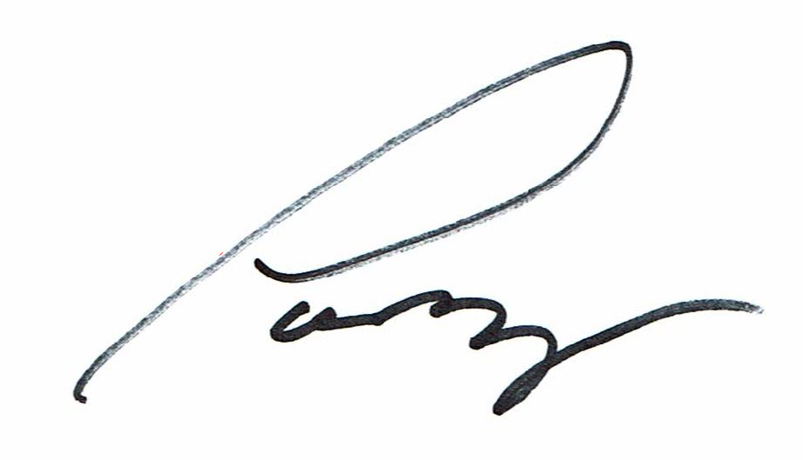

Patrick Hendry  
Vice President, Peer Advocacy, Supports & Services  
Mental Health America